**Chapter 2 Outline – Modeling Distributions**

Homework

|  |  |  |  |  |
| --- | --- | --- | --- | --- |
| 24 Monday    **TEST CH. 1**  **POW #1 assigned**  **(Due Mon. 12/1)** | 25 Tuesday  *2.1a*  #5, 7, 9ab, 12, 16, 33, 35, 36 | 26 Wednesday  NO SCHOOL | 27 Thursday  NO SCHOOL Thanksgiving | 28 Friday  NO SCHOOL |
| 1  *2.1b*  #19, 21, 27ab, 31, 37  **POW #1 DUE**  **POW #2 Asssigned** | 2  *2.2a*  #42, 44, 45, 47, 53ab, 56ab | 3  *2.2b*  #51, 65, 68-74 | 4  *Review Ch. 2*  (p. 136) R2.3, 6, 12  (p. 138) T2.1, 3, 8, 11, 12b | 5  **TEST CH. 2**  **POW #2 DUE** |

**For help, check out bhsstats.weebly.com!**

Things you need to know how to do

* Measure position using **percentiles** and standardized values, **z-scores**
* Interpret z-scores in context
* Understand **cumulative relative frequency graphs**
* Describe the effect of adding, subtracting, multiplying by, or dividing by a constant on the shape, center and spread of a distribution of data
* Approximate the median (equal-areas point) and the mean (balance point) on a density curve
* 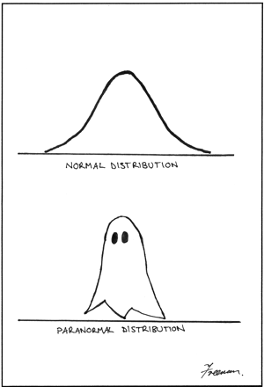Understand characteristics of **Normal curves**
* Use the **68-95-99.7 Rule**
* Use **Table A and calculator** to find:
* The proportion of values on an interval with the Normal curve
* A value with a given proportion of observations above or below it.
* Solve problems involving Normal Distributions
* Assess Normality of a data set
* ****Interpret a **Normal probability plot**