Day | Section | Objectives: Students will be able to… | Homework Problems | Homework Due
Tues. 12/10 | 3.1a | - Identify explanatory and response variables  - Make a scatterplot  - Interpret scatterplots (direction, form, strength, outliers) | 1, 5, 7, 10, 27, 28 | Wed. 12/11
Wed. 12/11 | 3.1b | - Know the basic properties of correlation.  - Calculate and interpret correlation. | 15, 17, 21, 25, 26, 29, 31, 32 | Thurs. 12/12
Thurs. 12/12 | 3.2a | - Use technology to find a least-squares regression line.  - Interpret the slope and y intercept of a least-squares regression line.  - Use the least-squares regression line to predict y for a given x.  - Calculate and interpret residuals. | 35, 37, 39, 41, 45, 53, 71-73  (#53 is referred to in tomorrow’s homework, so keep the data in your calculator) | Fri. 12/13
Fri. 12/13 | 3.2b | - Construct and interpret residual plots  - Interpret r²  - Identify the equation of a least-squares regression line from computer output.  - Recognize how the slope, y intercept, standard deviation of the residuals, and r² are influenced by extreme observations. | 49a, 55, 59, 61, 63a-c, 74–78 | Mon. 12/16
Mon. 12/16 | Chapter 3 Review |  | Stay tuned | Tues. 12/17
Tues. 12/17 | Chapter 3 Test
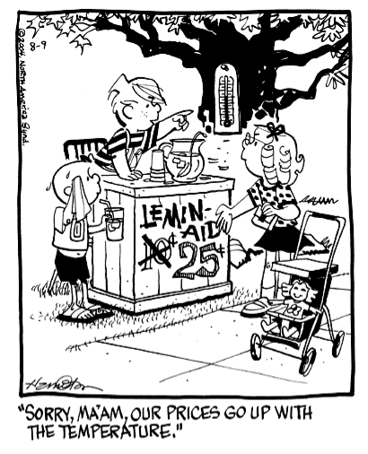

For help, check out
glausermath.weebly.com

