Matching Density Curves
Match each density curve to its context. The contexts are the variables that go along the x-axes. Justify each answer.
- _____________________  _________________________  _________________________  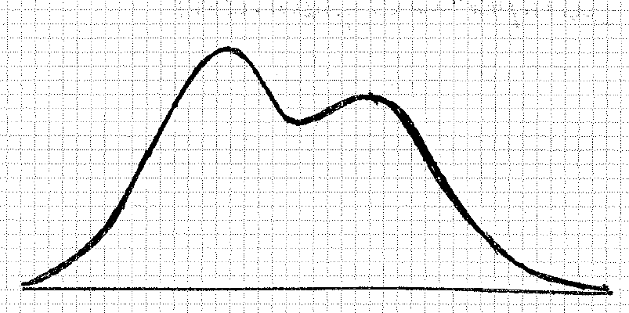 | - _____________________  _________________________  _________________________  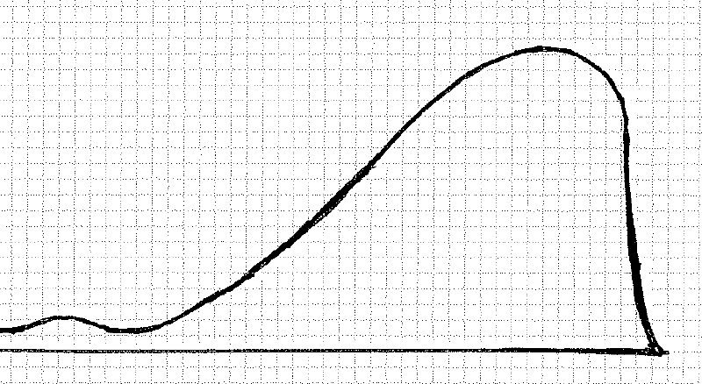 | - _____________________  _________________________  _________________________  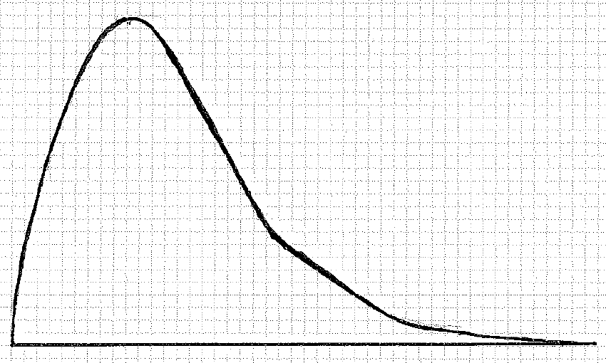
- _____________________  _________________________  _________________________ | - _____________________  _________________________  _________________________  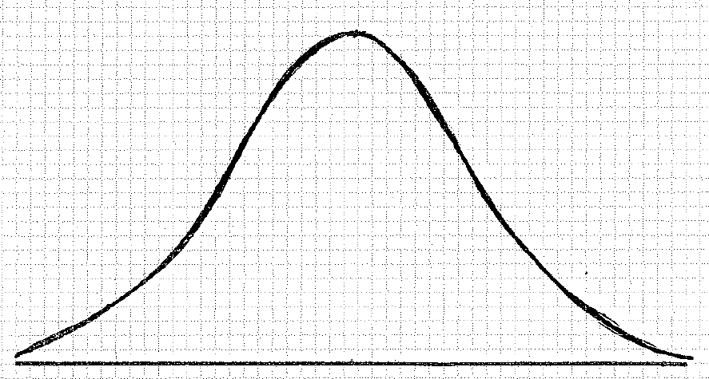 | - _____________________  _________________________  _________________________  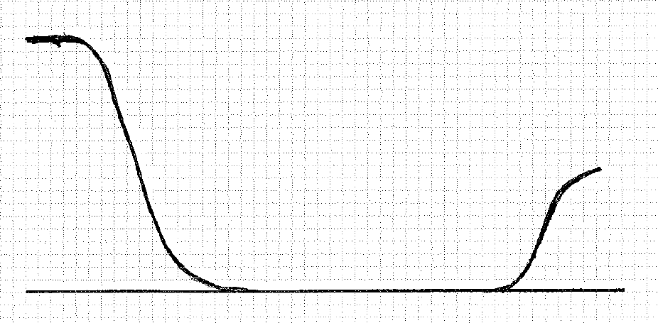

- Amount of time it takes for popcorn kernels to pop in the microwave
- Incomes
- Heights of adults
- Last digit of phone numbers
- Age of people who wear diapers
- Grades on an easy math test
Area Under the Normal Curve
IQ scores are Normally distributed, with a mean of 100 and a standard deviation of 15. The graph below shows the normal curve for IQ scores. Each square unit has an area of 0.01, or 1%.
- Shade the region between 100 and 115, and estimate the area to the nearest percent. Interpret what this means in terms of IQ scores. 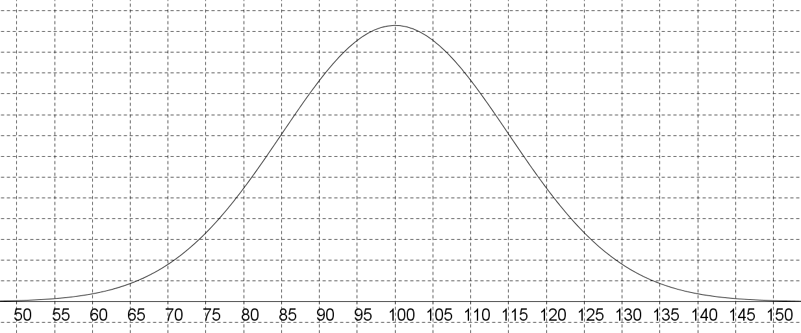

- Use your answer to #1 and symmetry to estimate the area between 85 and 115.
(This is within one standard deviation of the mean!)

- Shade the area between 70 and 130, and estimate the area to the nearest percent. Interpret what this means in terms of IQ scores. (This is within two standard deviations of the mean!)

- Use technology to calculate the exact values for the questions #1-3.
Applying the Normal Distribution
A cell phone battery life follows the normal distribution with a mean of 14 hours and a standard deviation of 3 hours.
  - Sketch a normal curve for this distribution below, clearly labeling the mean and one, two, and three standard deviations on each side.

  - If the factory rejects all batteries that last less than 11 hours, what percentage of the batteries would they reject?

  - Between what two values do 95% of cell phone batteries live?

  - With improvements to the technology, the battery life of the next model has a mean of 17 hours, with the same standard deviation. Graph the normal curve below, clearly labeling the mean and one, two and three standard deviations on each side.

  - For this new model, what percentage of the batteries would they reject, if they still reject all batteries that last less than 11 hours?

  - A battery lasting 20 hours corresponds to what percentile?

  - Instead of improving the mean, what if the factory improved the standard deviation (the cell phone batteries have a mean of 14 hours, but a standard deviation of only one hour)? With these parameters, what percentage of the batteries will be rejected, if all batteries less than 11 hours are rejected? Would it be better to improve the mean by 3 or change the standard deviation to one?

At some fast food restaurants, customers who want a lid for their drinks get them from a large stack near the straws, napkins, and condiments. The lids are made with a small amount of flexibility so they can be stretched across the mouth of the cup and then snugly secured. When lids are too small or too large, customers can get very frustrated, especially if they end up spilling their drinks. At one particular restaurant, large drink cups require lids with a diameter between 3.95 and 4.05 inches. The restaurant’s lid supplier claims that the diameter of their large lids follows a Normal Curve with a mean of 3.98 inches and a standard deviation of 0.03 inches. Assume that this claim is true.

- What percent of large lids are too small to fit? (Draw a normal curve and shade the area. Then calculate the answer using your calculator.)

- What percent of large lids are too big to fit? (Draw another normal curve and shade the area. Then calculate the answer using your calculator.)

- How would your answers to the above questions change if the mean diameter was adjusted to 4.00 inches?

