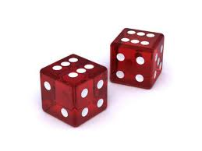
SIMULATIONS

The imitation of chance behavior

- State:
  - The problem
  - The possible outcomes
  - Probabilities

- Plan:
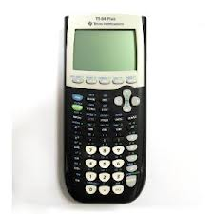
  - What random model will you use?
  - What does each outcome on the model represent in context of the problem?
  - What will you measure?
  - What exactly are you going to do?
  - Repeat how many times?

***Be clear enough so the reader could run your exact simulation from reading only your written explanation.

- Do:
  - Perform repetitions of the simulation
  - Show what you got

- Conclude:
  - Analyze your results
  - Estimate your probability
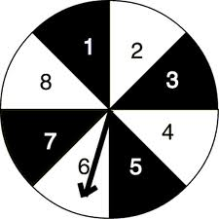
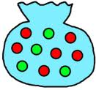
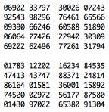
  - Answer the original question in context

